Segmental CAROLI’s disease
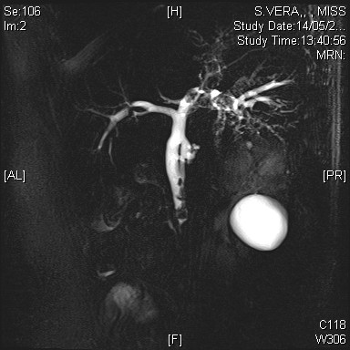
MRCP showing Segmental CAROLIs disease seen in Right Posterior Duct
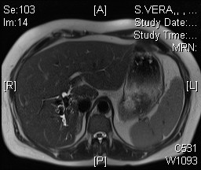
T2 MRI showing Segmental Caroli of Right Posterior Duct

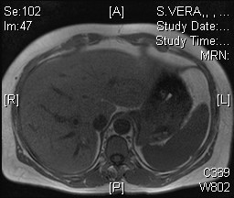
Segmental Carolis of Right Posterior duct with stones

