Right Adrenal Neuroblastoma
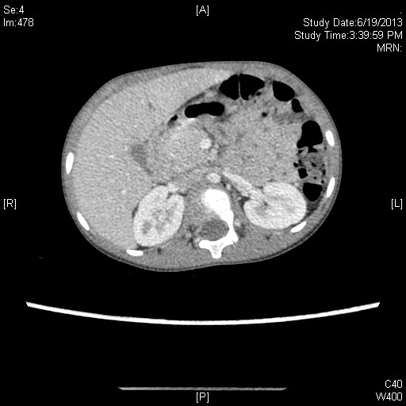
Right Adrenal Neuroblastoma with Absent CAVA below kidney
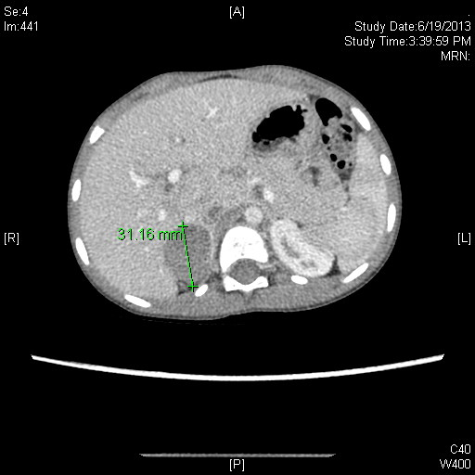
CECT with HYpodense 3cm lesion - Right Adrenal Neuroblastoma

