Pancreatic Psudocyst replacing whole pancreas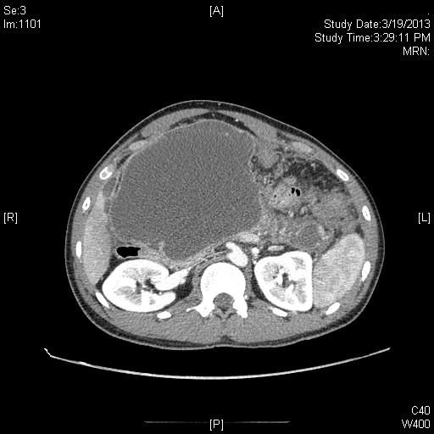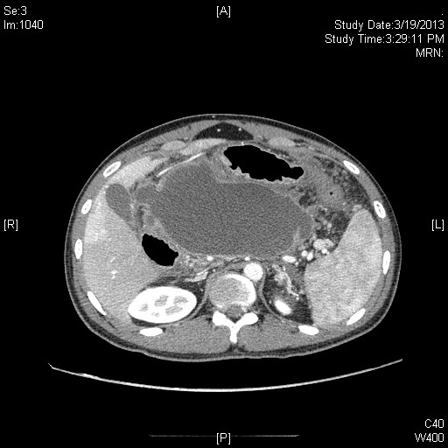
CECT showing Pancreatic Psudocyst replacing whole pancreas

