PVT on MRI and CT
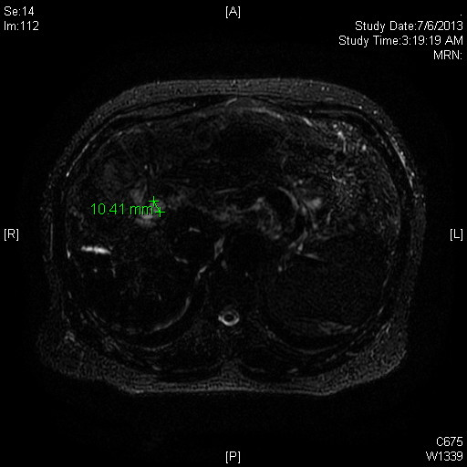
PVT appears white on MRI and Black in CT

