Multiple Splenic lesions
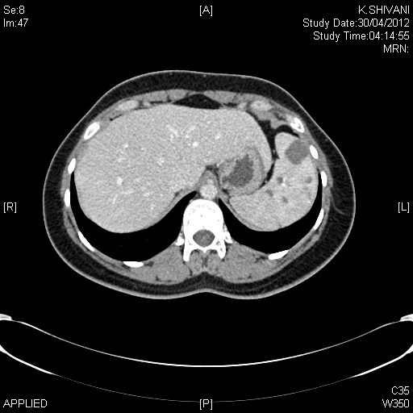
Multiple splenic lesions (Probable diagnosis when multiple ??Sarcoid if single then Hemangioma)

