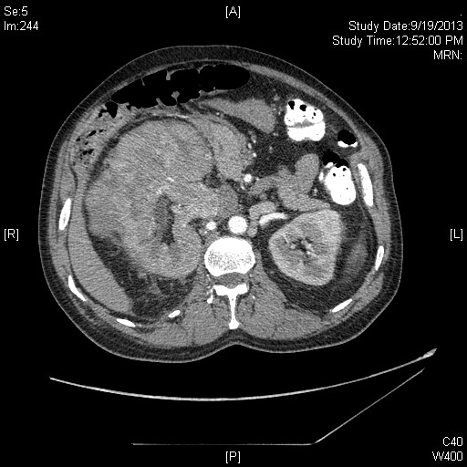

Renal cell carcinoma arterial phase with IVC thrombosis.

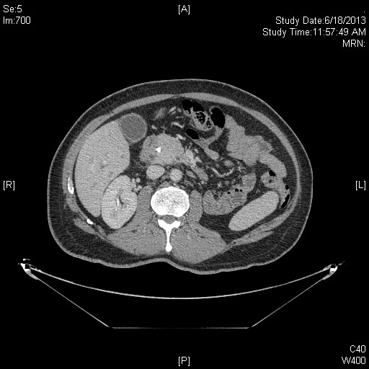

Renal cell carcinoma with pancreatic met, hyperdense and obstructing.

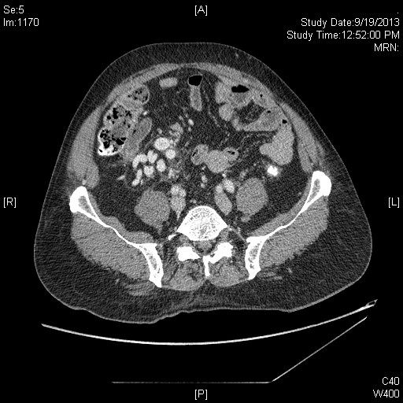

Renal cell carcinoma with exaggerated gonadal veins due to IVC thrombosis.

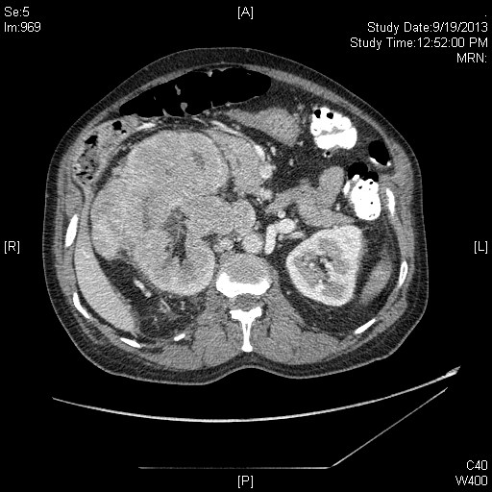

Renal cell carcinoma portal phase with IVC thrombosis.

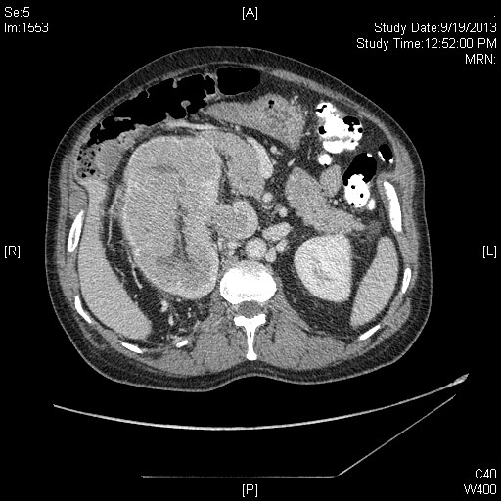

Renal cell carcinoma with delayed phase