Groove Pancreatitis
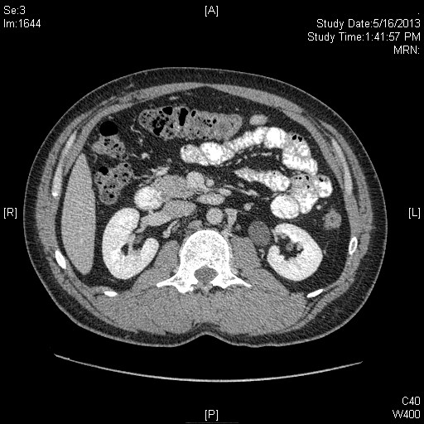
CT showing Groove Pancreatitis

