Gall bladder neck carcinoma
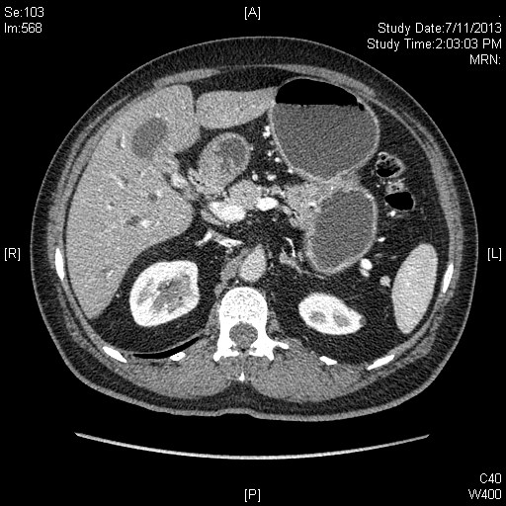
CT showing Gall bladder cancer involving neck .

