Gaint psudo aneurysm of hepatic artery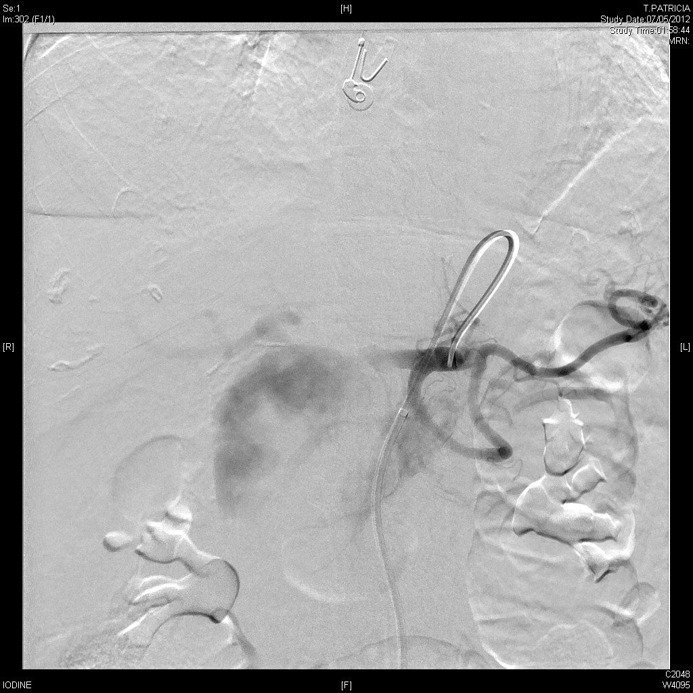
Angiogram showing giant psudoaneurysm of hepatic artery
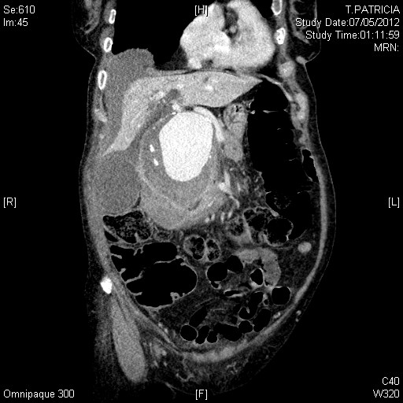
CT Sagittal view showing gaint hepatic artery psudoaneurysm
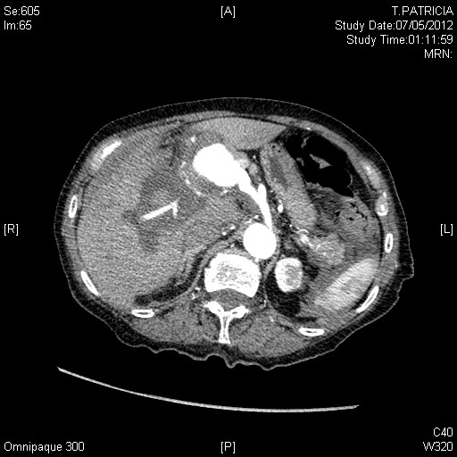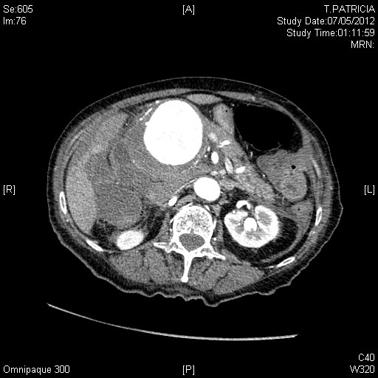
CECT showing Giant Hepatic artery psudoaneurysm
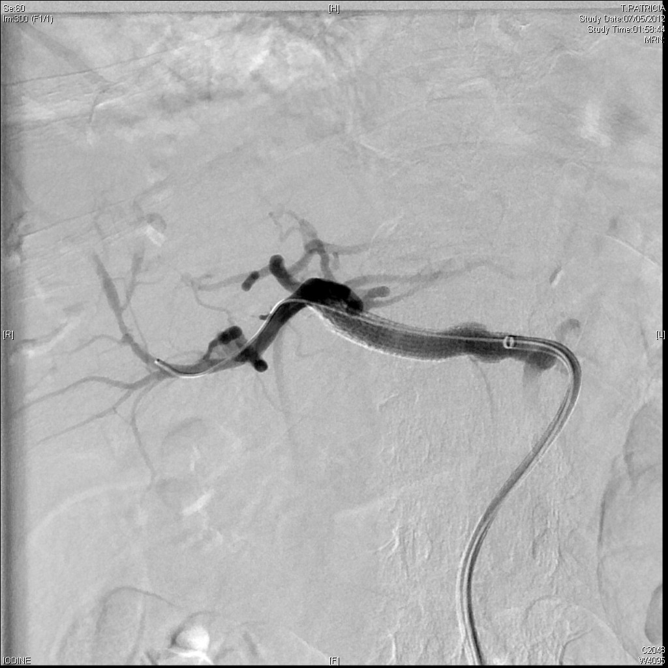
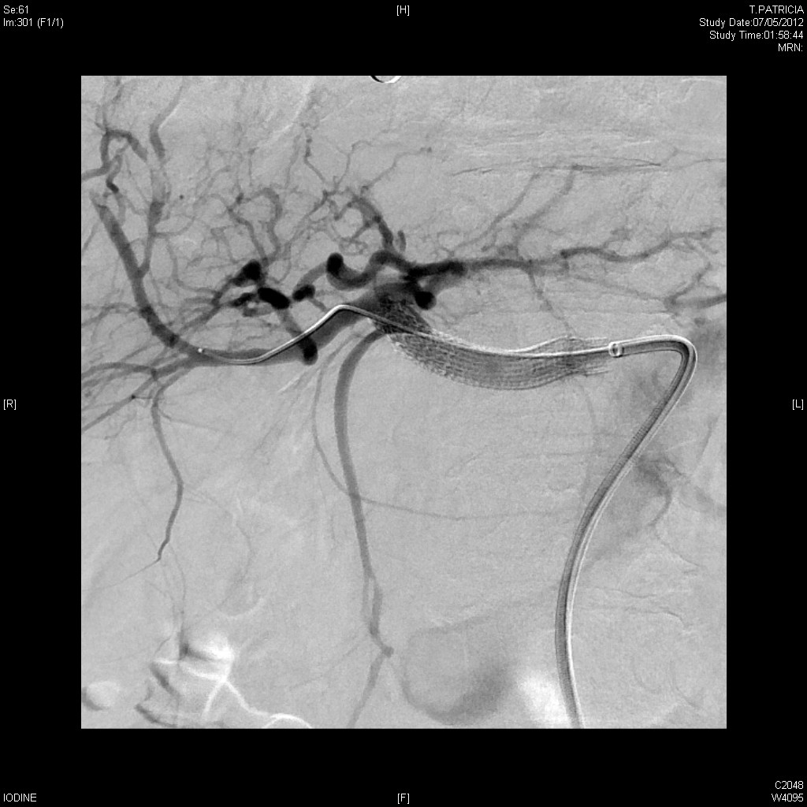
Angiography stent placement in Giant hepatic artery psudoaneurysm

