Classic Air in Ischemic gut and Portal vein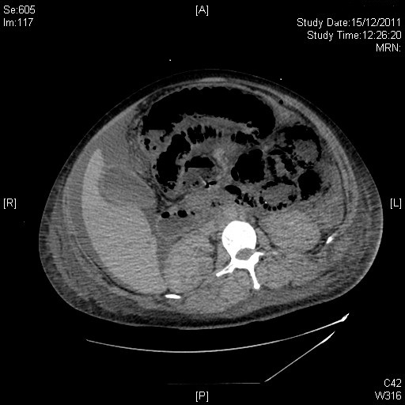
CT showing Classic air in Ischemic gut wall.
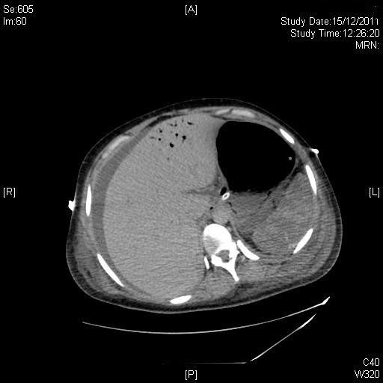
CT showing Air in portal vein from Ischemic gut

