Top caval anastamosis stricture. (OLT with caval replacement)

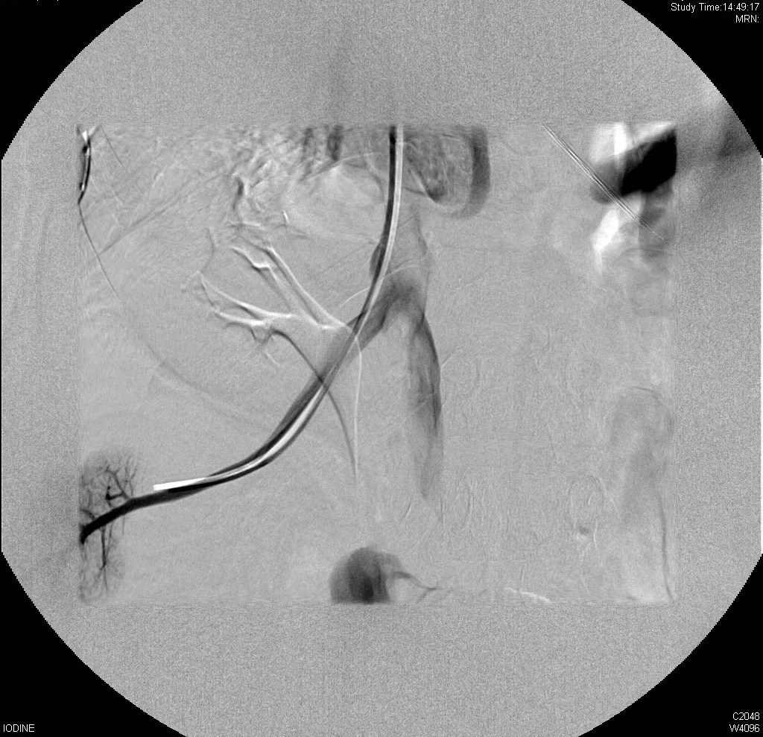

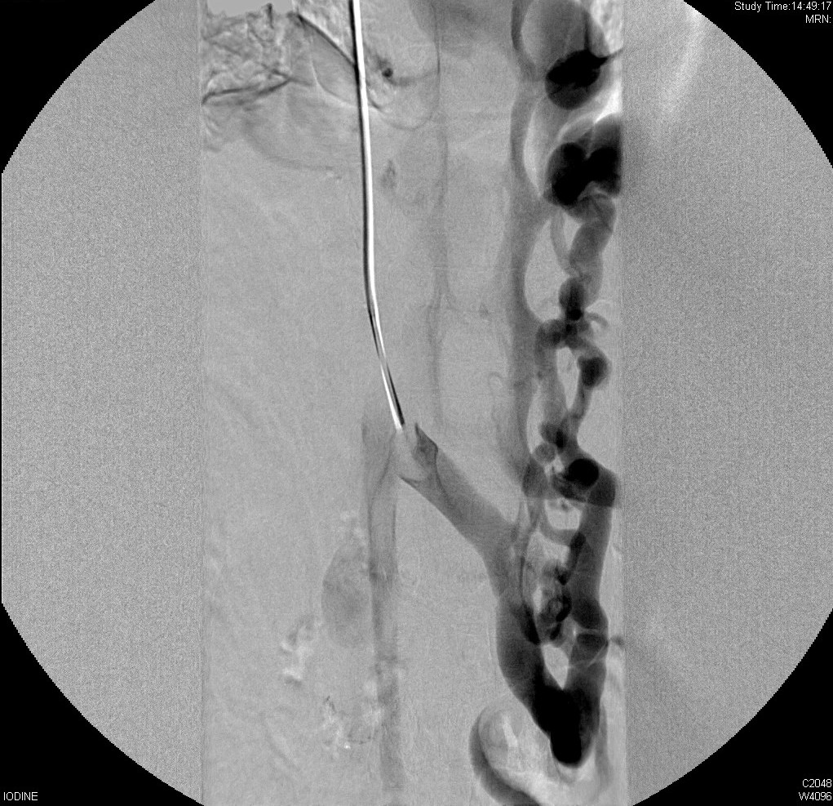

Direct caval venography via a right internal jugular vein
approach demonstrated recurrent occlusion or critical
stenosis of the supra hepatic cava. Consequently, there is
retrograde decompression of the liver into the infra-hepatic
IVC and an established ascending lumbar/hemi-azygos venous
collateral circulation.
The free hepatic vein and infra-hepatic venous pressure were
measured at 15 mm with an RA pressure of 12 mm and a low
HVPG of 4 mm. This would therefore indicate a low
decompressing hepatic venous gradient despite the retrograde
flow. In addition, it is difficult to align this finding to
the protein-losing enteropathy and lymphangiectasia.
The supra paracaval segment was dilated to 10 mm with
partial restoration of supra paracaval flow but with
significant recoil of the stenotic segment. This observation
coupled with the short impact from the intervention of
10/12/10 would indicate that balloon dilatation alone will
not produce any long-term effect.
A transjugular biopsy was conducted to determine whether
this occlusion is resulting in significant venous
congestion, thereby warranting further intervention. Any
intervention would only be a suprahepatic caval stent and
there is only a very narrow segment of IVC to the RA upon
which to lay the stent without compromising the right renal
vein and right hepatic vein.
The right kidney lies in an abnormal ectopic position. This
is probably because it migrated to this position when there
was a left lobe segmental graft site following
re-transplantation, there is a whole graft overlying the
right renal space.
The procedure was carried out and the GA with
no immediate complications and following informed written
consent.

