**BUDDCHIARI SYNDROME WITH LHV PATENT**

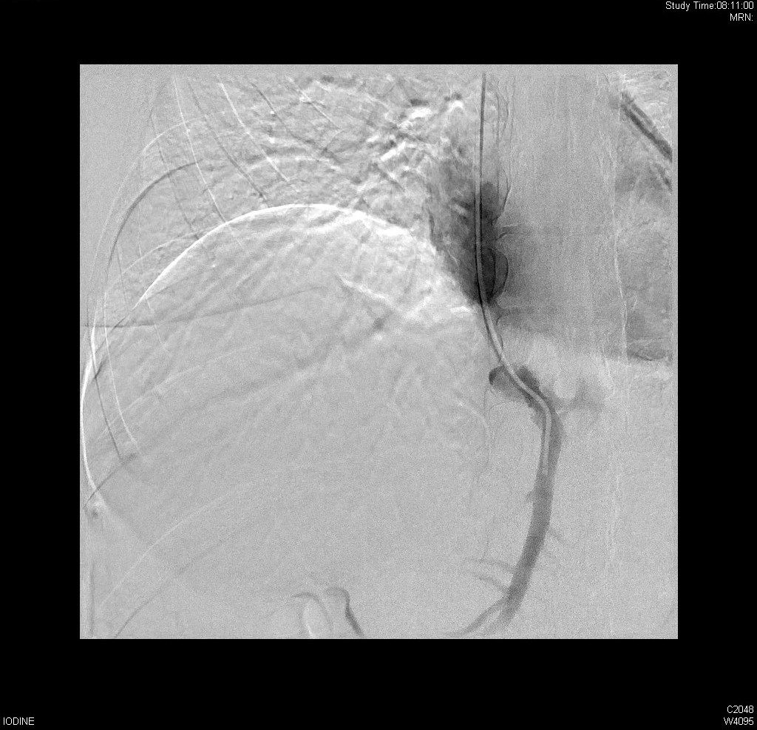

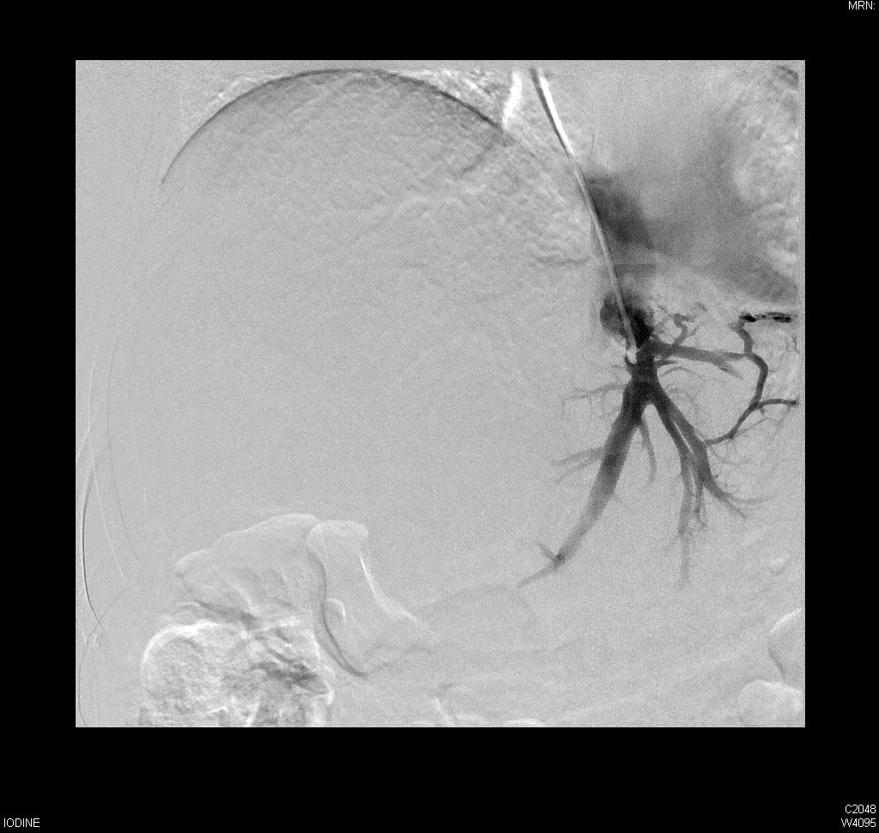

**BUDDCHIARI with LHV patent and Decompressing**

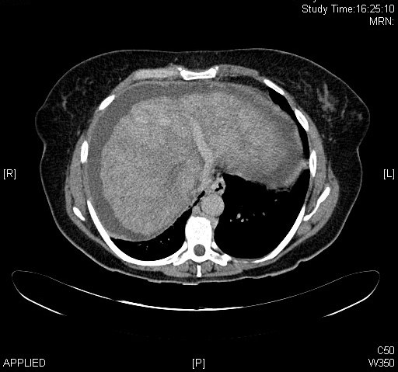

**CECT Buddchiari with LHV patent and Decompressing.**