Primary Sclerosing cholangitis, Bleed into the dilated strictured ducts

23 yr old female presented with pain, temperature and decreased Hb. PMH- PSC.

On CT- Arterial bleed into a stricured LHD only visible because a CT done incidentally 4 days ago showed a simple LHD stricture. Without knowledge of this dilated duct on the previous CT, the second CT would ve been reported as a tumor with a bleed into it.

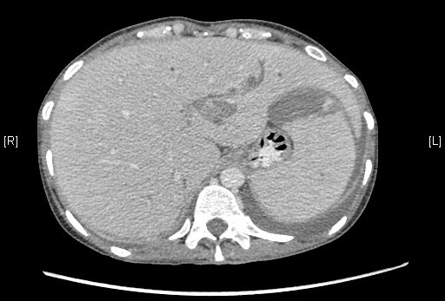

Pic 1- PSC with LHD stricture, 24th Sept.

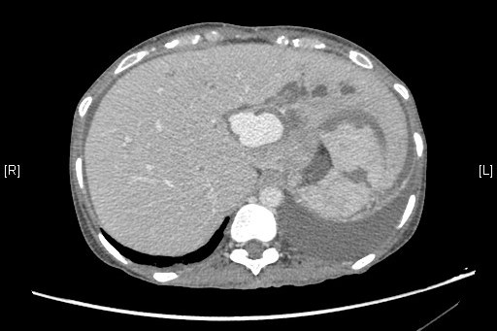

Pic 2: LHD stricture with arterial bleed, 5 days later.

.

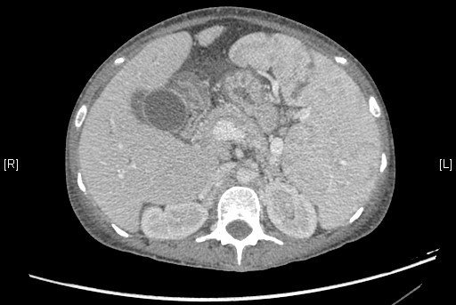

Pic3: Obvious splenomegaly, same patient