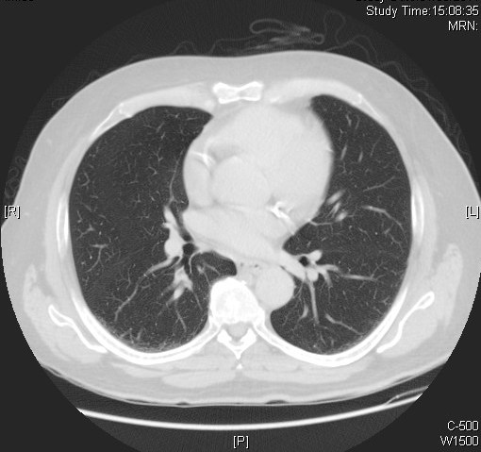

**Calcified Coronary Arteries**

Cardiac computed tomography (CT) for Calcium Scoring uses special x-ray equipment to produce pictures of the coronary arteries to determine if they are blocked or narrowed by the buildup of plaque – an indicator for atherosclerosis or coronary artery disease (CAD). The information obtained can help evaluate whether you are at increased risk for heart attack.

The extent of CAD is graded according to your calcium score:

|  |  |
| --- | --- |
| **Calcium Score** | **Presence of CAD** |
| 0 | No evidence of CAD |
| 1-10 | Minimal evidence of CAD |
| 11-100 | Mild evidence of CAD |
| 101-400 | Moderate evidence of CAD |
| Over 400 | Extensive evidence of CAD |

(Source : https://www.radiologyinfo.org/en/info.cfm?pg=ct_calscoring)