**Two arteries reconstruction in Cholagiocarcinoma – Good outcome**

On preop CT noted small CHD Cholangio Carcinoma, involving RHA for a 1 cm length, as otherwise patient is well etc, PV clear decided to operate. Plan: Lt hepatectomy as left PV possibly involved and right lobe good volume . Plan roux en y onto RHD. If required remove 1cm segment of RHA and reanastomose.

BUT…at surgery the RPHA was joining the RHA below or proximal to the tumor so that we need to do two arterial anastamosis(each one half the size originally planned) separately to the two arteries of the right lobe below a roux to the RHD.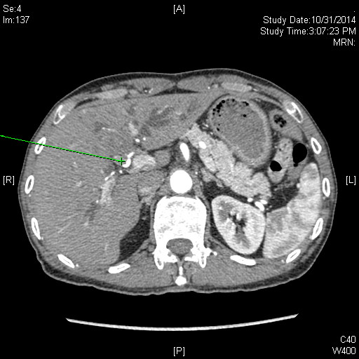

CT showing tumor involving the right hepatic artery.

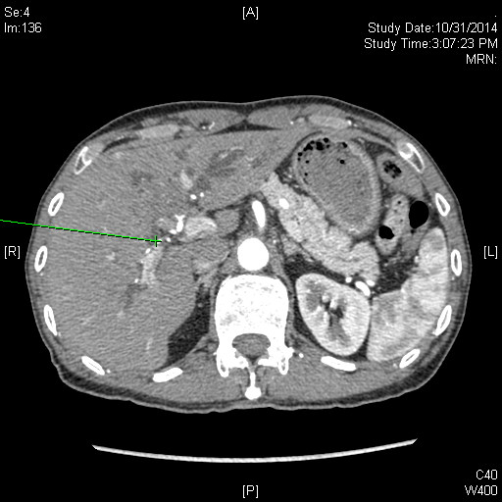

CT showing Right Posterior artery joining right hepatic artery proximal to the tumor(retrospective).

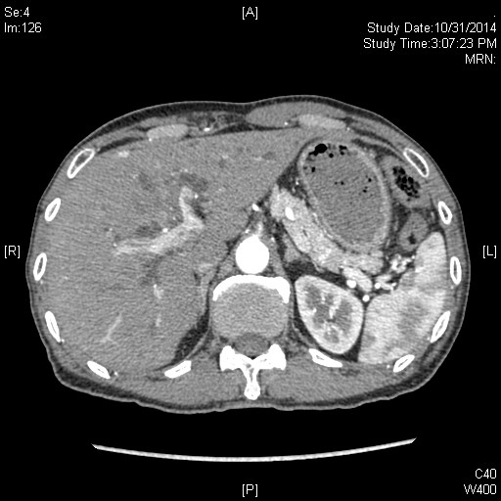

CT showing tumor involving the left portal vein.